**TO WHOMSOEVER IT MAY CONCERN**

I hereby authorise William O’Neil India Pvt Ltd or its representatives to verify information presented in my employee application or resume and to procure and investigate report or consumer report for this purpose.

I grant authority to the bearer of this letter to access or be provided with details of

* My previous employment record
* My qualification /Degree
* Information in respect to my character from the record wanted by local authority.

I declare that all the above information is true to the best of my knowledge and any misrepresentation of the facts furnished by me is found to be false, I could be denied employment/be terminated.

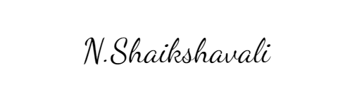

Signature of the Candidate :

Name:Niruganti.Shaikshavali

Place:Giddalur,Prakasam Dist(523357),AP

Date:03-10-2024